Name: Devansh Gupta Student ID: dxg397

EECS 484 Computational Intelligence

Problem Set 2: Feed forward Neural Networks with Error Back propagation

1. Influence of Learning Factor

Ps2_fdfwd_net:
eta=0.0001, iterations=103103
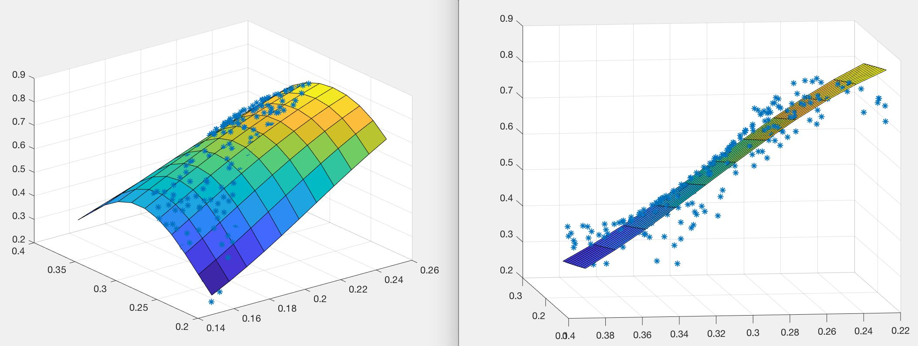

eta=0.1, iteration=75075
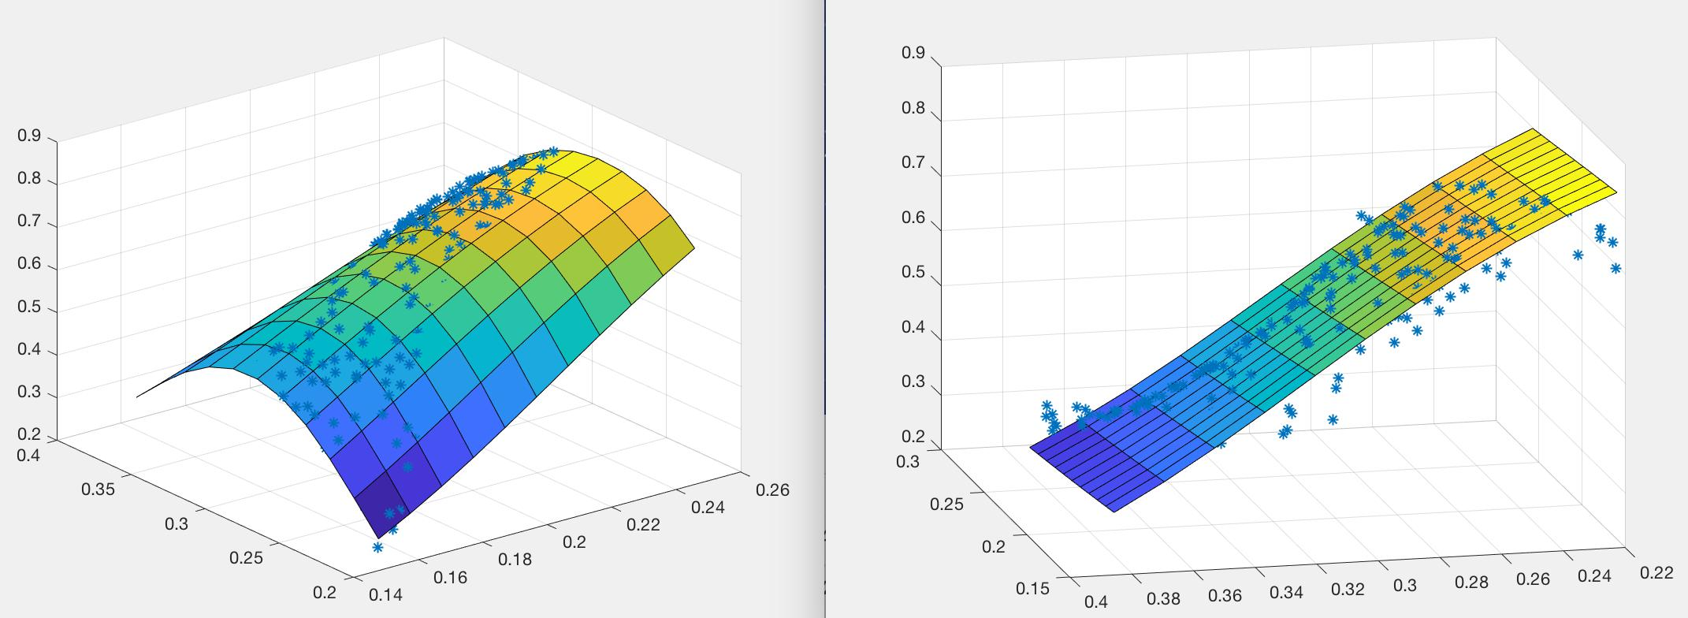

ETA=1.8

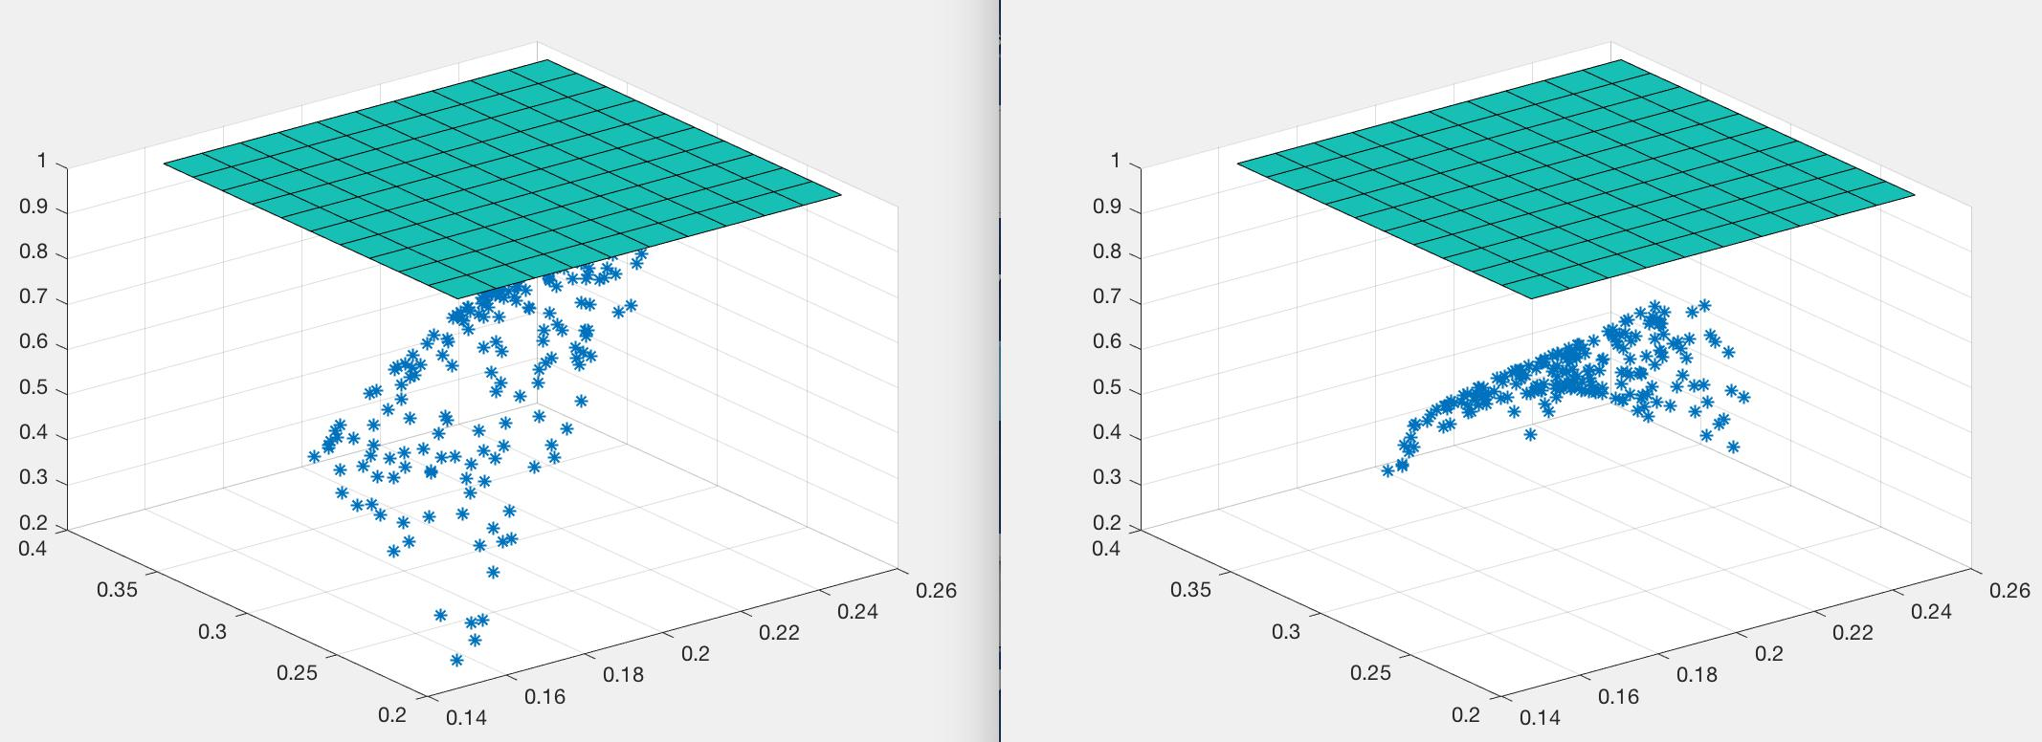
Based on these three experiments’ result, we can notice that with the higher learning rates, the number of iterations will decrease. But with higher learning rate, the simulation chart will not as smooth as the lower learning rates. Also, if the learning rate is too high, it may cause the divergence.
Name: Devansh Gupta Student ID: dxg397

ps2_fdfwd_net_presets
eta=0.001, iteration=2424
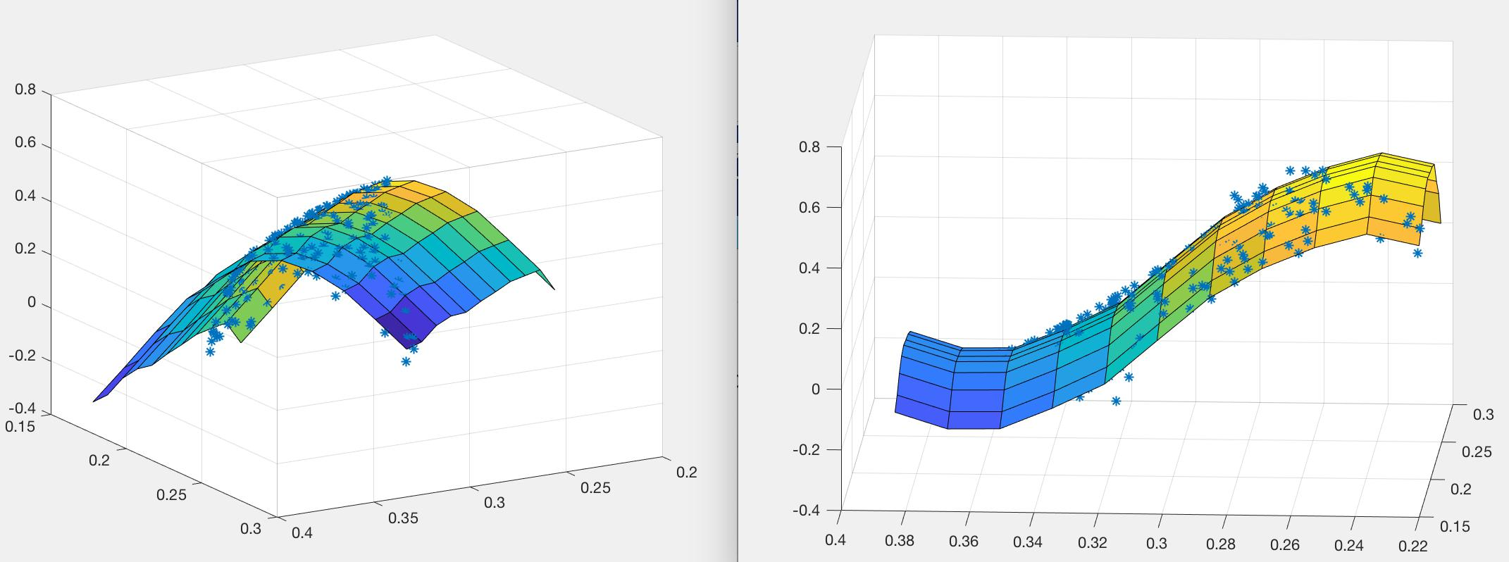

eta=0.01, iteration=13130
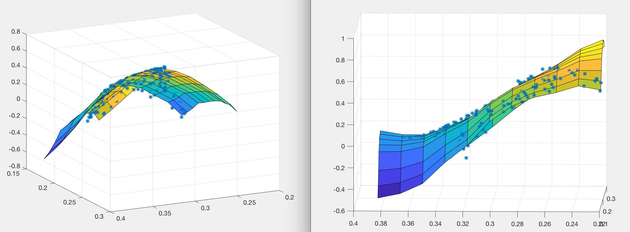

In the preset, with the higher learning rates, the number of iterations will increase. Also, I tried to set the learning rate as the 1, the result shows that the simulation chart will not converge.
Name:Devansh Gupta Student ID:dxg397

Accuracy achieved in training

ps2_fdfwd_net:

eta=0.02, interneurons=5, iteration=55045
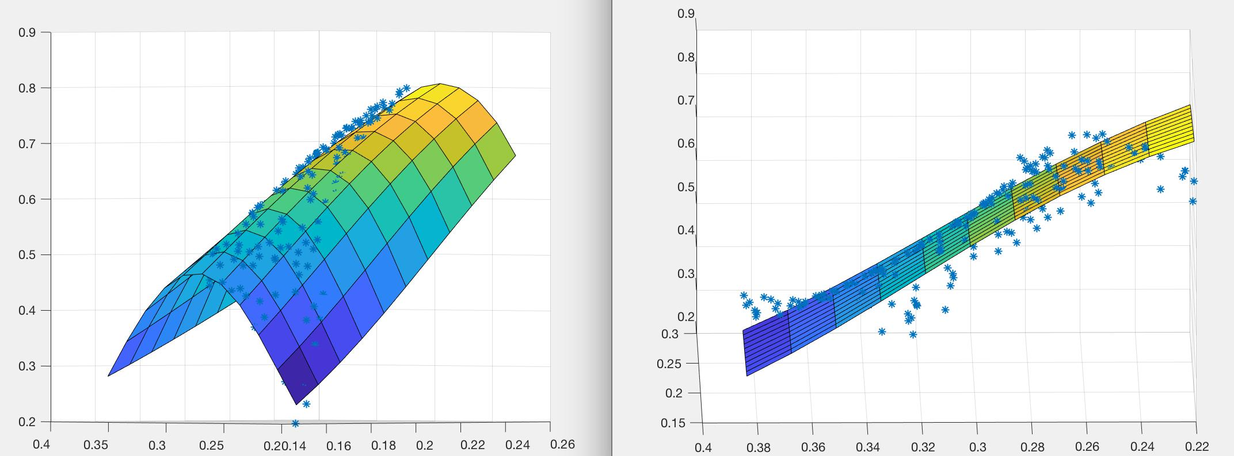

eta=0.02, interneurons=25, iteration=84045
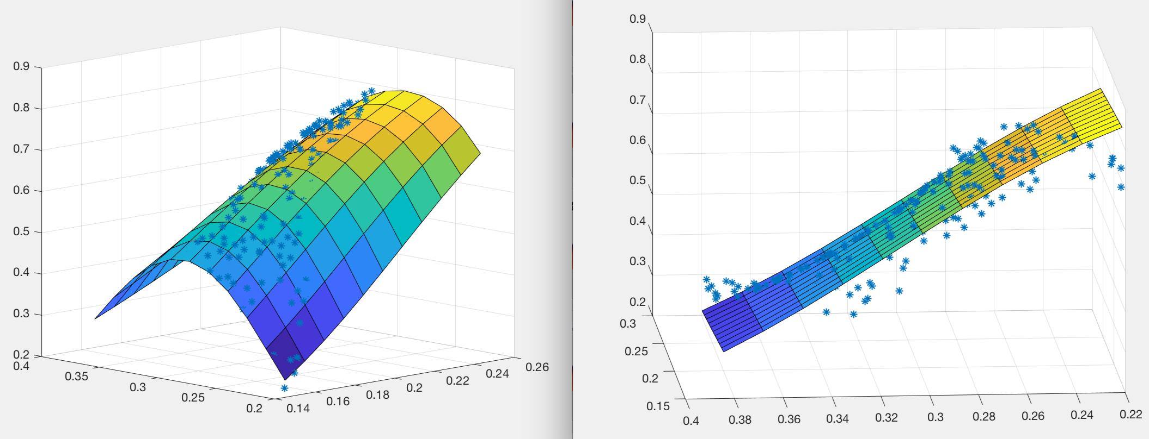

eta=0.02, interneurons=50, iteration=212344
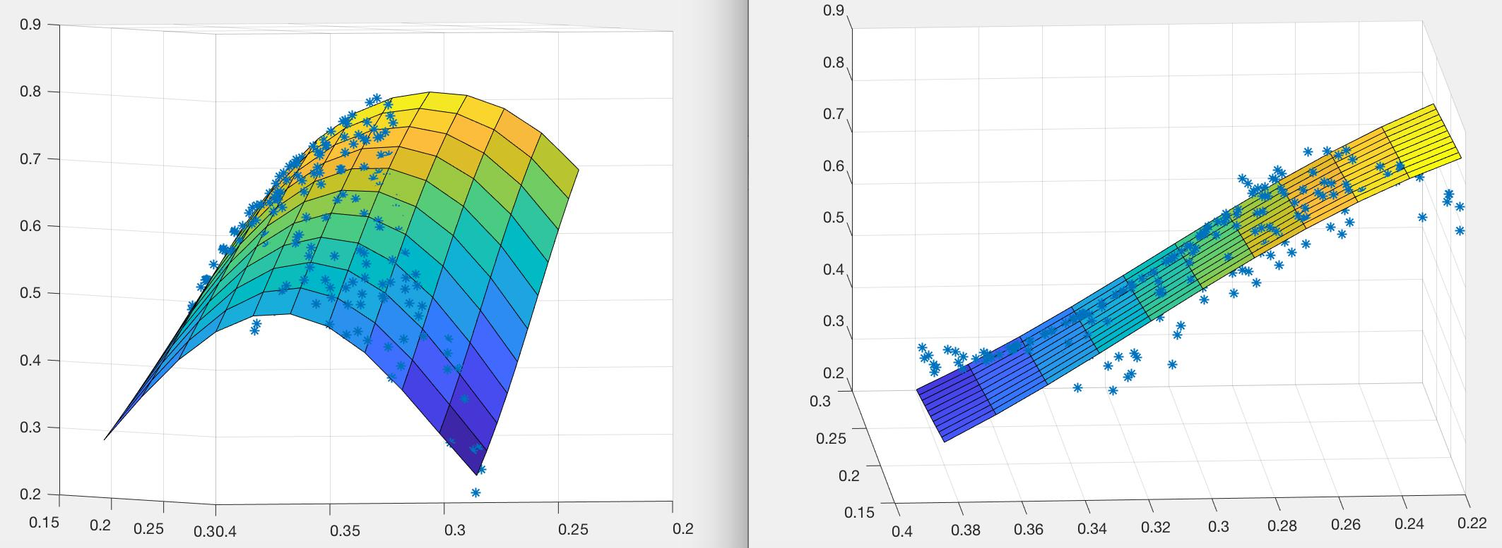

Based on these three experiments’ result, we can notice that with the same learning rates, if we are using more interneurons, the number of iteration will be greater. Even though, the number of iteration increased, but the simulation chart is more smooth than the lower
Name:Devansh Gupta Student ID: dxg397

number of interneurons.

ps2_fdfwd_net_presets
eta=0.001, interneurons=25 , iteration=1818
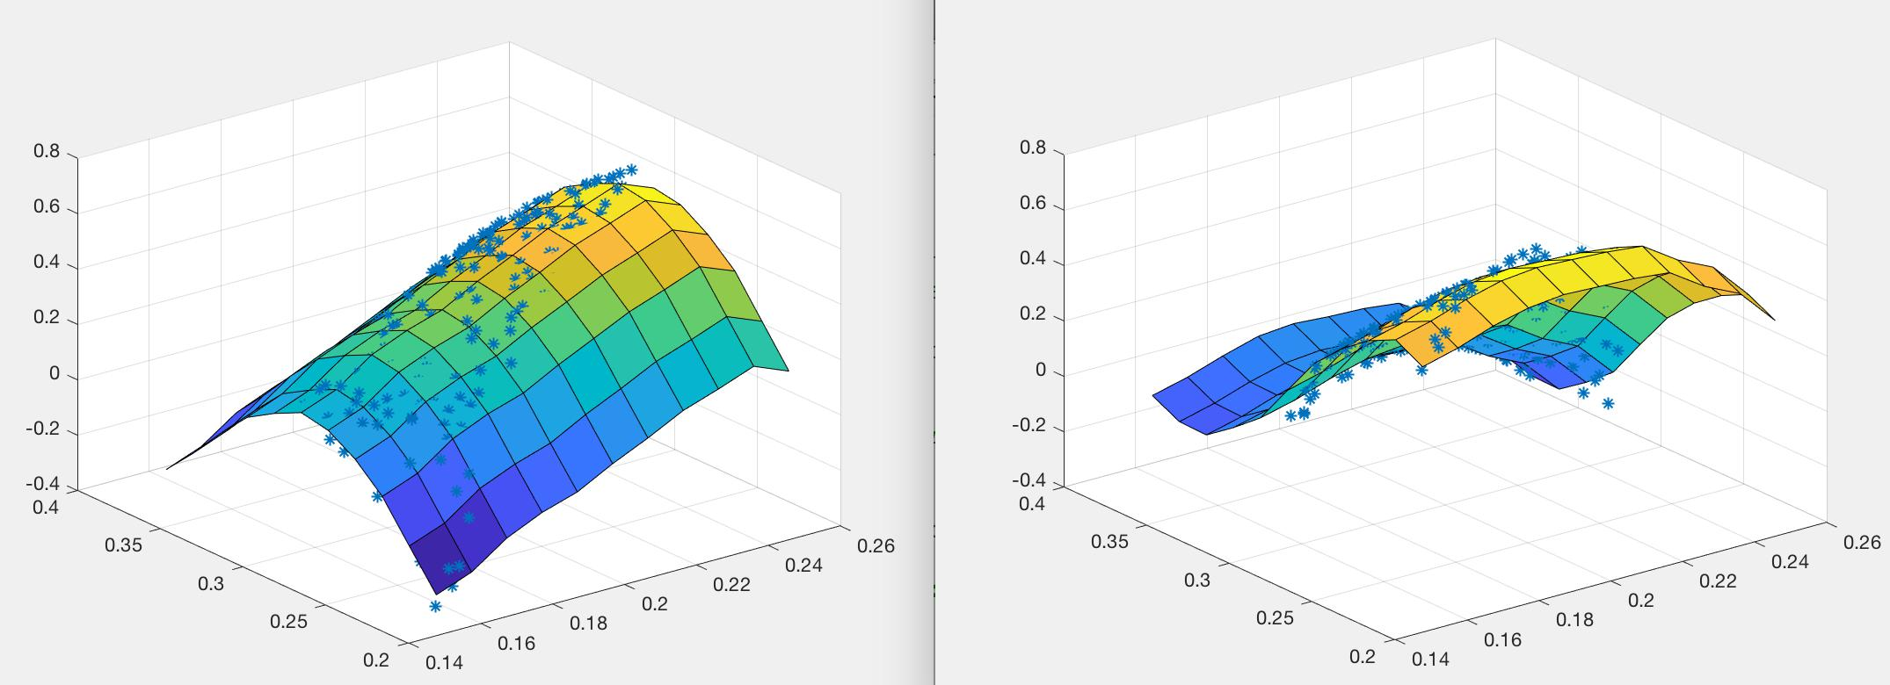

eta=0.001, interneurons=50 , iteration=2024
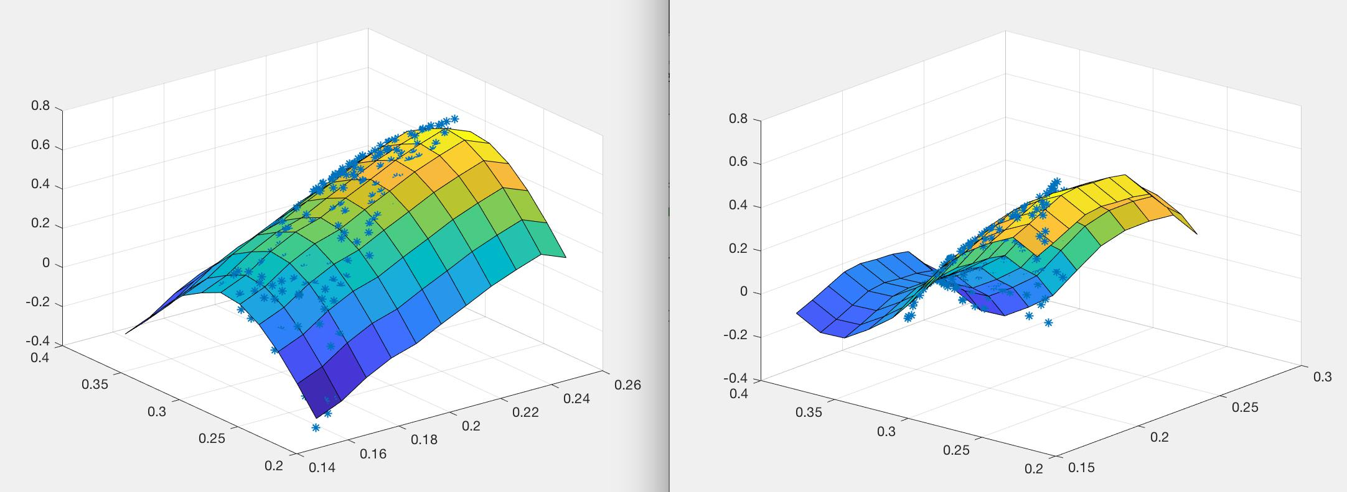

eta=0.001, interneurons=75 , iteration=3304
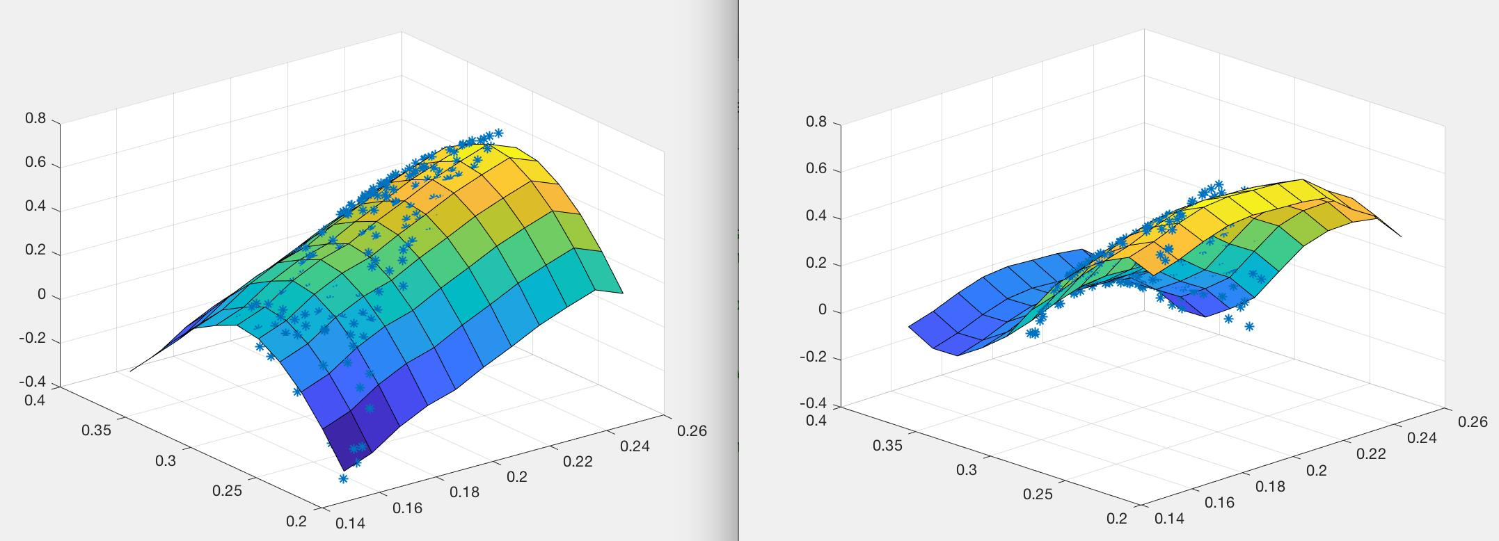

Based on these three experiments’ result, we can notice that with the same learning rates, if we are using more interneurons, the number of iteration will be greater.

3. Differences between 1 vs. 3hidden layers

The main difference between one hidden layer and three hidden layers is the three hidden layers are able to training the data faster, which I believe is because of the at the
Name:Devansh Gupta Student ID:dxg397

first two layer of three layers, these layers will pre-modifier the input data to make it closer to the result that we want.

Non-preset: eta=0.001, interneurons=20, iteration=96075
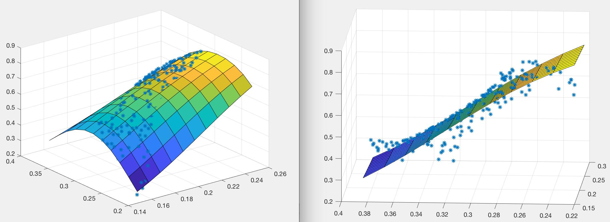

preset: eta=0.001, interneurons=20 , iteration=1818

Also, based on these two results, we can notice that one hidden layer’s training data are more smooth.

4. Alternative values for the fixed weights.

Changed the W1, I changed the dx to the dx=(xmax-xmin)/(Npreset_nodes-0.3). With the same learning rates and same interneurons numbers. The iteration has become lager, in this case the number of iteration has become 16716(the original number is 2424).

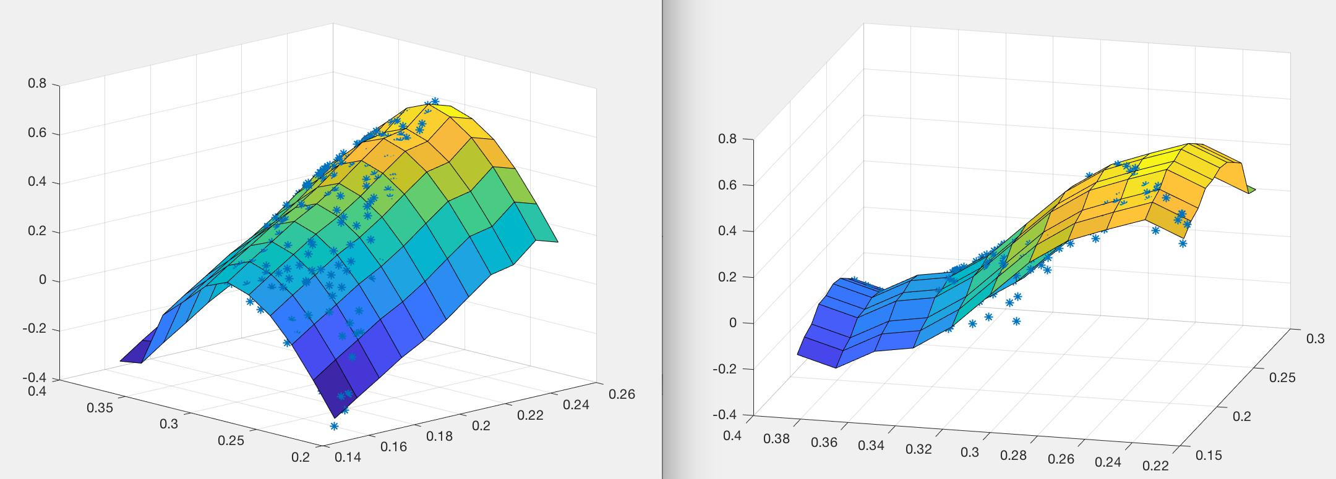
Name:Devansh Gupta Student ID:dxg397

if I changed the dx to the dx=(xmax-xmin)/(Npreset_nodes-2). With the same learning rates and same interneurons numbers. The iteration has become smaller. In this case the number of iteration has become 1919(the original number is 2424).
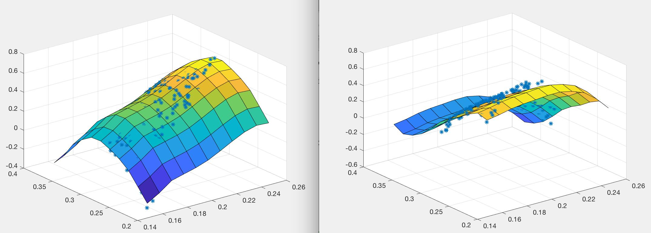

Changed the W2, I changed the w2 to the w2(i, i+1)=-1. With the same learning rates and same interneurons numbers. The iteration has become smaller. In this case the number of iteration has become 1100(the original number is 2424).
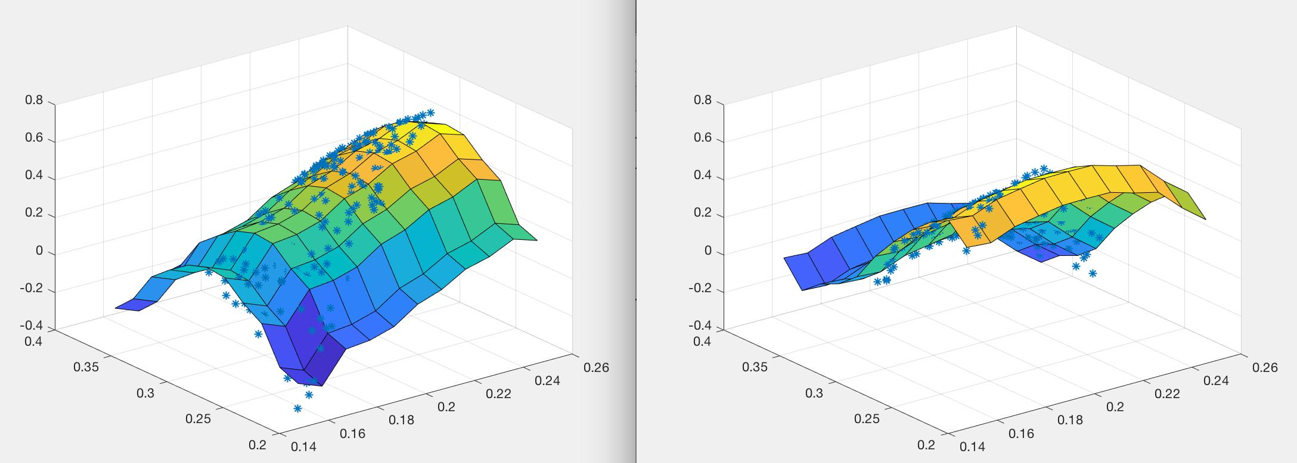

I also changed the w2 to the w2(i, i+1)=-3. With the same learning rates and same interneurons numbers. The iteration has become bigger. In this case the number of iteration has become 78100(the original number is 2424).
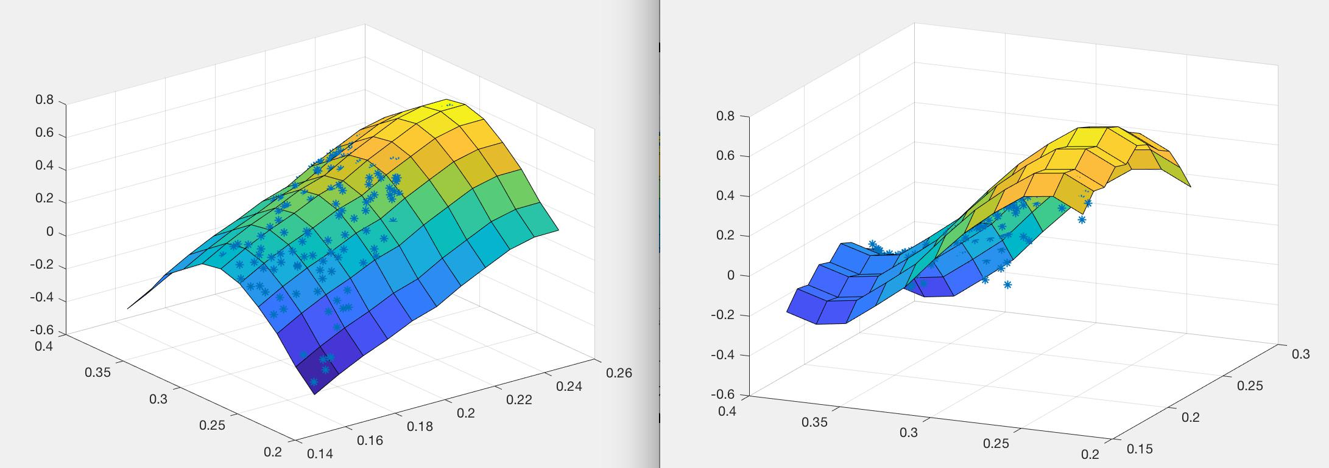

Name:Devansh Gupta Student ID:dxg397

5. Other changes

In the preset, I changed the phix1_code and phiy1_code 2 to two, which means the first layer output function is linear instead of logsig function. The number of iteration has increase to 166750, which is much higher than the original.
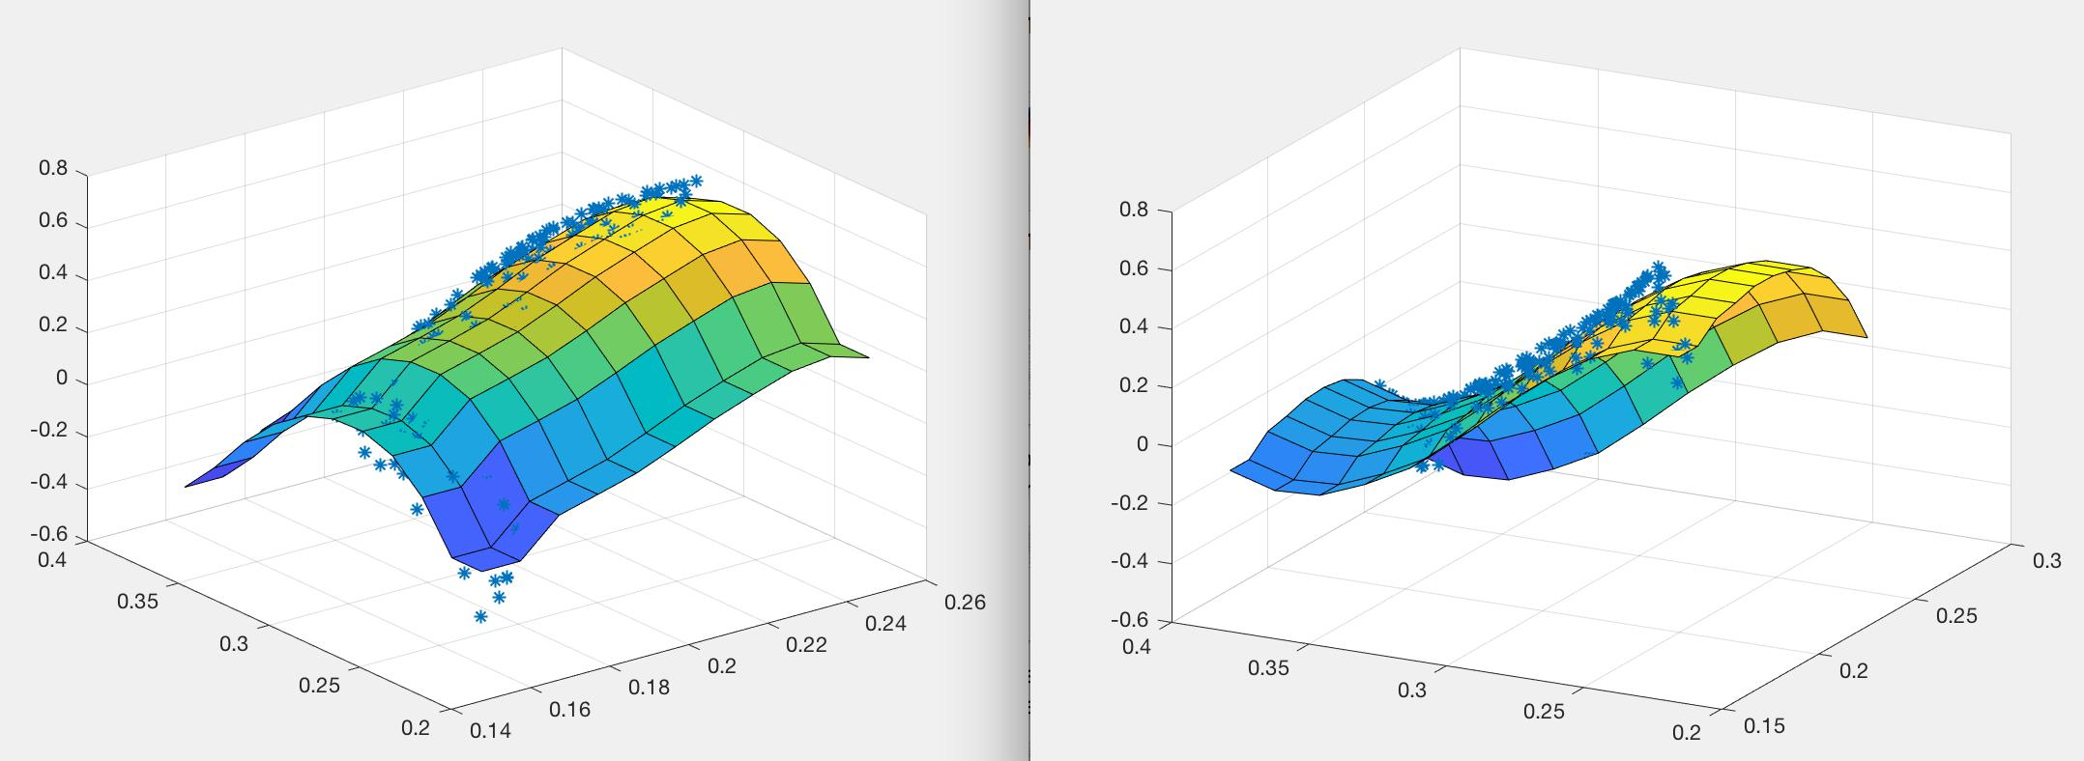

if I changed the phix2_code and phiy2_code 2 to two, which means the second layer output function is linear instead of logsig function. The number of iteration does not changed too much, which is 2222. But the training data’s simulation chart is not as smooth as it used to be.
